**Sennheiser Powers the Future of Flexible Workplaces with GPT Space&Co**

***Sennheiser TeamConnect Ceiling Microphone solutions bring reliability, simplicity and function to GPT Space&Co’s elegant meeting rooms***

***Sydney, Australia, 27 May 2025,*** As flexible work transforms how and where people collaborate, GPT Safeco, one of Australia’s leading providers of premium meeting environments has partnered with Sennheiser to deliver future-ready spaces that adapt to any team, setup or workstyle. The rollout features Sennheiser’s TeamConnect Ceiling (TCC) microphone technology as the backbone of the scalable AV setup that supports today’s hybrid workforce. In partnership with AV integrator Programmed, the meeting rooms now feature Sennheiser’s TeamConnect Ceiling 2 (TCC 2) and the newer TeamConnect Ceiling M (TCC M) microphones across key spaces, enabling clear, reliable, and automated audio in any room layout.

**Creating tomorrow’s meeting spaces**

Unlike traditional co-working models, GPT Space&Co focuses exclusively on premium meeting and event rooms, with technology designed to be as invisible and intuitive as possible.

In 2024, GPT Space&Co opened four new A-Grade sites, including a flagship at 181 William Street in Melbourne, designed to provide seamless, on-demand meeting spaces for businesses that prioritise quality, flexibility, and integrated technology.

Each meeting space is designed to accommodate a wide range of use cases, from executive briefings to team workshops and hybrid presentations. These rooms are walk-in ready with Microsoft Teams Rooms (MTR), BYOD support, and an AV experience that requires no technical training.

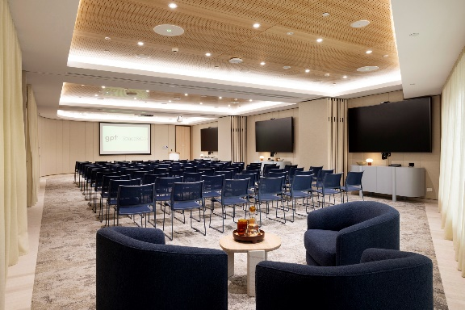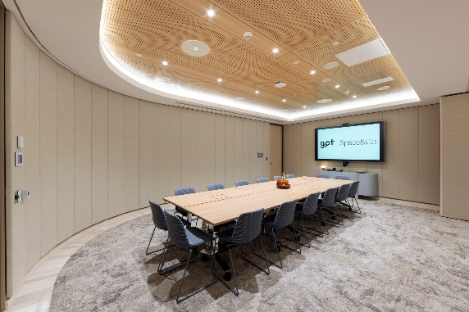

*GPT Space&Co meeting rooms are not only aesthetically sleek and modern, but feature cutting edge AV technology to enable a seamless work experience.*

“For the larger rooms, flexibility was a key focus,” explains Camden Webb, Flexible Workspace Technology Manager at The GPT Group. “Traditionally, when AV equipment is placed on or under tables, it limits how the furniture and consequently the space can be used. Whether the room is set up in theatre style, boardroom style or workshop style, users still receive the same high-quality experience.”

Webb adds that ceiling-mounted audio has transformed the user experience. “The Sennheiser TeamConnect Ceiling microphones ensure that no matter where someone is located, they can be heard clearly. Remote participants can follow discussions and feel engaged, even if they are not physically present.”

**Adaptive technology for reconfigurable spaces**

Rooms like Petition and Verdict use TCC 2 microphones, allowing layouts to change daily without any impact on audio performance. The microphones auto-adjust to the speaker’s position thanks to patented beamforming technology, removing the need for tabletop devices.

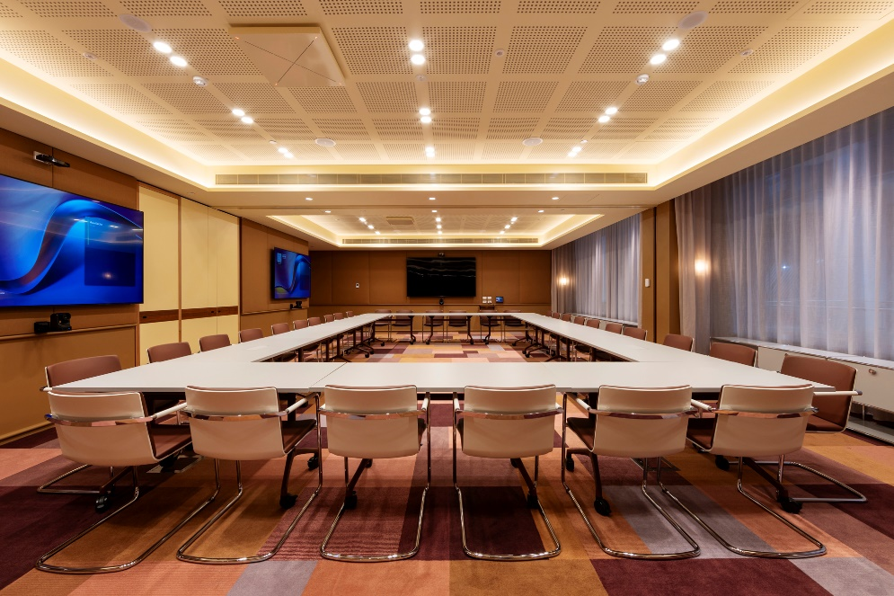

*The Petition and Verdict spaces are fitted with TCC 2 mic arrays along the ceiling, ensuring high quality audio while staying low profile.*

Anthony Aloi, AV Solutions Manager at Programmed, notes that while fixed microphones can work well, they restrict modularity. “Ceiling-mounted microphones give us the flexibility dynamic spaces require.” Webb agrees, adding that the system provides granular control over pickup zones to minimise background noise.

This integration is made even more valuable by the system’s compatibility with platforms such as Microsoft Co-Pilot, supporting AI-enhanced features like transcription, meeting summaries and intelligent notetaking.

**Premium AV meets architectural design**

The *Chamber* room at GPT Space&Co’s 181 William Street location is a 50-person event space with wall-to-wall glass and a unique geometric layout. Programmed specified three TeamConnect Ceiling M microphones for the space, offering powerful performance in a smaller, circular form factor suited to the room’s shape and acoustics.

*The Chamber room has embedded three Sennheiser TCC Ms to seamlessly cover the space for hybrid meetings and events.*

“Combining three TCC Ms gave us great coverage of the space while allowing our team to program exclusion zones to minimise street noise,” says Aloi. “They are more cost effective than the TCC 2 and they look amazing.”

To preserve the room’s design, Programmed worked with Sennheiser and the builder to colour-match the microphones to the ceiling finish. “In a premium space, integration is about more than function. The technology should disappear into the architecture,” says Aloi. The Judge boardroom uses the same setup for design and performance consistency.

*An example of the TCC Ms colour match to the waffle ceiling cover, bringing together design and function to the meeting room.*

**Designed for every user, every setup**

With a broad range of users ranging from lawyers to creatives, the solution had to be intuitive and reliable. “These rooms are intuitive and support all devices,” says Aloi. “The technology stays out of the way so people can focus on the meeting.”

Webb notes that while a site manager is always present, their role is customer-facing, not technical. “Every guest needs to walk in, start their meeting, and go. Sennheiser’s microphones make that possible – they’re invisible to the user but essential to the experience.”

**A clear standard for tomorrow’s meeting spaces**

As hybrid work evolves, GPT Space&Co’s latest rollout sets a new benchmark for flexible, elegant, and functional meeting spaces. With Sennheiser, they’ve built intelligent AV environments that scale with the needs of modern teams.

For Aloi, the mission is simple: technology should empower people to connect, not complicate the experience. With Sennheiser, GPT is delivering a collaboration experience that’s consistent, confident, and ready for the future.

###

**About the Sennheiser brand**

We live and breathe audio. We are driven by the passion to create audio solutions that make a difference. Building the future of audio and bringing remarkable sound experiences to our customers – this is what the Sennheiser brand has represented for more than 75 years. While professional audio solutions such as microphones, meeting solutions, streaming technologies and monitoring systems are part of the business of Sennheiser electronic GmbH & Co. KG, the business with consumer devices such as headphones, soundbars and speech-enhanced hearables is operated by Sonova Holding AG under the license of Sennheiser.

[www.sennheiser.com](http://www.sennheiser.com)

[www.sennheiser-hearing.com](http://www.sennheiser-hearing.com)

|  |  |
| --- | --- |
| **Local Press Contacts**  Daniella Kohan  [Daniella.kohan@sennheiser.com](mailto:Daniella.kohan@sennheiser.com)  [+1 860 598 7420](tel:+1%20860%20598%207420)  Kirsten Spruch  kirsten.spruch@sennheiser.com  +1 (860) 598-7484 | Hotwire Australia  [sennheiseranz@hotwireglobal.com](mailto:sennheiseranz@hotwireglobal.com) |